Public Toilets Emergency
Cromarty has an emergency and we need your help!
Following this mindless vandalism of the Allan Square Public Toilets (with an estimated cost of £20k!), your C&DCC has pressed The Highland Council for an urgent response to reinstate this vital amenity.
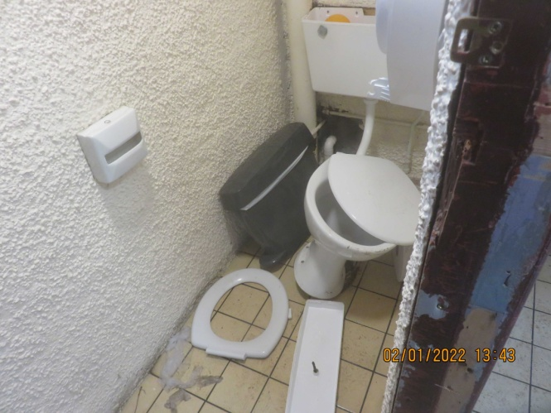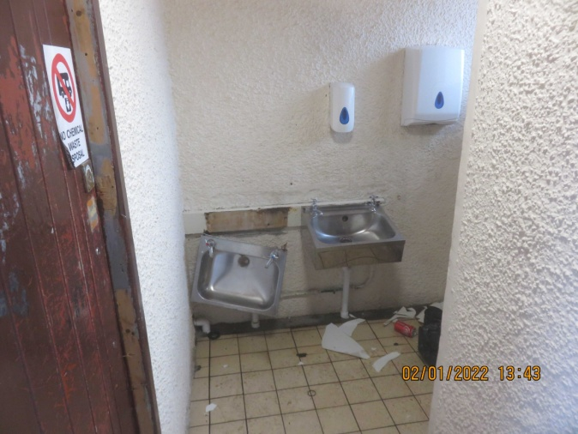
The situation is that the Highland Council’s Property Maintenance Service, on instruction from the Highland Amenities Office, has let the job to a contractor who cannot start because they are awaiting the delivery of the new sinks! We have stressed that it is unacceptable for Cromarty to have no access to Public Toilets. Apart from being an essential service to the local community our usual flow of tourists will stop visiting the Town.
The Highland Amenities office says that “the supply issues are out with our control” and that “If there was no vandalism then there would not be a problem and businesses would not have reason to worry. Vandalism impacts all of us and adds considerable costs to our already very tight budget for operating 74 toilets and 45 Comfort Schemes in Highland, unfortunately those doing the damage do not consider the impact the impact on the local economy & community.”
WE NEED YOUR HELP
Businesses and individuals can complain that the THC’s failure to restore this essential amenity, in a timely fashion, is fast becoming a Health & Safety concern that will become more than that unless THC put pressure on their Property Maintenance Service to deliver a solution NOW. The C&DCC will continue to press, our request for temporary facilities were refused and the Disabled toilet has no water supply until repair works are completed, but everyone can increase this pressure by registering a complaint.
To register a complaint under Health & Safety use the website link https://www.highland.gov.uk/report
A reference number should be given and start an audit trail that relevant HC departments can, and MUST, follow up. Hopefully with HC Councillor Elections in May, THC must listen to the Cromarty community.

